1. Describe the structure of an artificial neuron. How is it similar to a biological neuron? What

are its main components?

ANN- An Artificial Neural Network consists of highly interconnected processing elements called nodes or neurons. These neurons work in parallel and are organized in an architecture. The nodes are connected to each other by connection links. Each neuron carries a weight that contains information about the input signal.

Main Components are- weights , biases, input, outputs, and nodes

2. What are the different types of activation functions popularly used? Explain each of them.

Different types of activation functions are

Sigmoid:

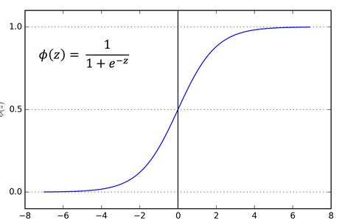



Advantages:

1. Very smooth Gradient – prevent jumps
2. Output range is between 0 to 1 hence reduce solution space.

Disadvantages:

1. Prone to gradient vanishing – choose better weights to avoid it
2. Time consuming due to exponential operations(latency (training and prediction is low)).

RELU:

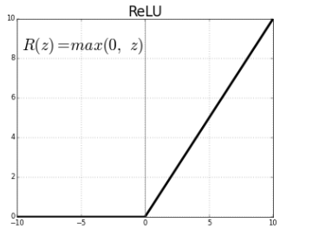

Domain (-infinity,infinity)

Range(0,infinity)

Advantages-

1.faster calculation.

Disadvantage-

1, for negative input we have dying relu problem

2.not symmetric

3. at 0 , derivative is ND.

Leaky RELU

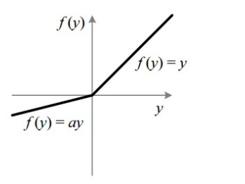

Exponential linear unit (ELU)

Scaled exponential linear unit (SELU)

Soft-max

Hyperbolic tangent:



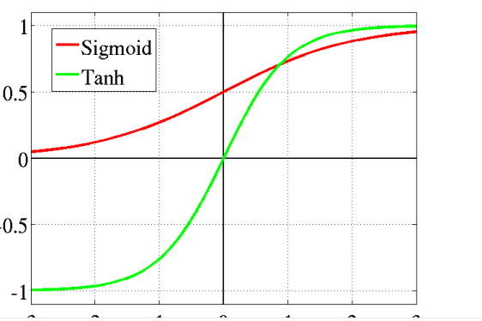

Domain(-infinity to infinity)

Range (-1,1)

Advantages-

1. smooth gradient

2.symmetric to origin(mean=0).

3.suitable for hidden layer.

1. Explain, in details, Rosenblatt’s perceptron model. How can a set of data be classified using a

simple perceptron?

The Rosenblatt’s Perceptron (1957) The classic model. The Rosenblatt’s Perceptron was designed to overcome most issues of the McCulloch-Pitts neuron : it can process non-boolean inputs; and it can assign different weights to each input automatically; the threshold \(\theta\) is computed automatically; A perceptron is a single layer Neural Network.

2. Explain the basic structure of a multi-layer perceptron. Explain how it can solve the XOR

problem.

Multilayer perceptrons are sometimes colloquially referred to as "vanilla" neural networks, especially when they have a single hidden layer. An MLP consists of at least three layers of nodes: an input layer, a hidden layer and an output layer. Except for the input nodes, each node is a neuron that uses a nonlinear activation function

3. What is artificial neural network (ANN)? Explain some of the salient highlights in the

different architectural options for ANN.

Architectures of Neural Network:

ANN is a computational system consisting of many interconnected units called artificial neurons. The connection between artificial neurons can transmit a signal from one neuron to another. So, there are multiple possibilities for connecting the neurons based on which the architecture we are going to adopt for a specific solution. Some permutations and combinations are as follows:

There may be just two layers of neuron in the network – the input and output layer.

There can be one or more intermediate ‘hidden’ layers of a neuron.

The neurons may be connected with all neurons in the next layer and so on …..

So let’s start talking about the various possible architectures:

An artificial neuron is a mathematical function conceived as a model of biological neurons, a neural network. Artificial neurons are elementary units in an artificial neural network. The artificial neuron receives one or more inputs (representing excitatory postsynaptic potentials and inhibitory postsynaptic potentials at neural dendrites) and sums them to produce an output (or activation, representing a neuron's action potential which is transmitted along its axon)

4. Explain the learning process of an ANN. Explain, with example, the challenge in assigning

synaptic weights for the interconnection between neurons? How can this challenge be

addressed? he

In ANN we have data going in input layer then hidden layer then output layer where we predict the output based on dummy weights and biases we assign in the very beginning , this is called forward propagation.

The predicted output is then compared with the actual output with the help of cost function and then we update the weights in such a way that the cost function is reduced. Its called back propagation and we do the updates inn such as way that cost function is minimised.

5. Explain, in details, the backpropagation algorithm. What are the limitations of this

algorithm?

In ANN we have data going in input layer then hidden layer then output layer where we predict the output based on dummy weights and biases we assign in the very beginning , this is called forward propagation.

The predicted output is then compared with the actual output with the help of cost function and then we update the weights in such a way that the cost function is reduced. Its called back propagation and we do the updates inn such as way that cost function is minimised

Limitations of back propagation are-

The actual performance of back propagation on a specific problem is dependent on the input data.

Back propagation algorithm in data mining can be quite sensitive to noisy data

You need to use the matrix-based approach for backpropagation instead of mini-batch.

8. Write short notes on:

1. Artificial neuron:

Artificial Neural Networks contain artificial neurons which are called units. These units are arranged in a series of layers that together constitute the whole Artificial Neural Networks in a system. A layer can have only a dozen units or millions of units as this depends on the complexity of the system. Commonly, Artificial Neural Network has an input layer, output layer as well as hidden layers. The input layer receives data from the outside world which the neural network needs to analyze or learn about. Then this data passes through one or multiple hidden layers that transform the input into data that is valuable for the output layer. Finally, the output layer provides an output in the form of a response of the Artificial Neural Networks to input data provided.

Artificial neural networks are trained using a training set. For example, suppose you want to teach an ANN to recognize a cat. Then it is shown thousands of different images of cats so that the network can learn to identify a cat. Once the neural network has been trained enough using images of cats, then you need to check if it can identify cat images correctly. This is done by making the ANN classify the images it is provided by deciding whether they are cat images or not. The output obtained by the ANN is corroborated by a human-provided description of whether the image is a cat image or not. If the ANN identifies incorrectly then back-propagation is used to adjust whatever it has learned during training. Back-propagation is done by fine-tuning the weights of the connections in ANN units based on the error rate obtained. This process continues until the artificial neural network can correctly recognize a cat in an image with minimal possible error rates.

1. Multi-layer perceptron:

It is nothing much a feed forward ANN with no back propagation.

3. Deep learning:

4. Learning rate:

Learning rate is a Hyper parameter defined by us in order to control the rate of learning.